Premium Reporting User Guide

Introduction
Your company has purchased Premium Reporting, powered by Tableau, in conjunction with Audit Manager to help you better manage your auditing business. Tableau is visual analytics, business intelligence tool that helps businesses transform their data, in a meaningful way, to guide them in solving problems or empowering your organization.

Access Premium Reporting
Tableau can be accessed in two ways: 1) directly in Audit Manager; or, 2) through Tableau Server.

Through Audit Manager
There will be a new menu option titled Embedded Analytics on the main menu within Audit Manager. To access your custom dashboards and standard dashboards click on the menu option.
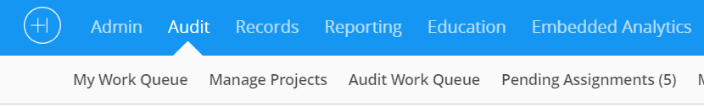
Most users of Audit Manager will access Tableau through Audit Manager. The standard premium dashboards and your custom dashboards. Users will only need the ability to access dashboards through Tableau Server for one of two situations: 1) the user will be modifying existing dashboards or creating new dashboards; 2) your organization has restricted access to some dashboards.

Through Tableau Server
If you need access to Tableau Server because you are either going to be 1) modifying or creating dashboards using a Tableau Explorer license; or 2) you have access to restricted dashboards. Healthicity will provide a URL address to the Tableau Server that contains only your organization’s data. This will take you to a login page that looks like the one below.
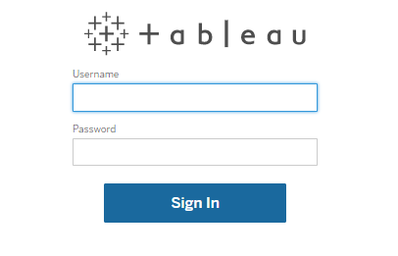
To use Tableau Server, you must have credentials for the server in addition to your Audit Manager credentials. These credentials will be provided to users as elected by your organization. If you think you should have credentials call support@healthicity.com.

Select A Dashboard
Once you are in either Audit Manager or Tableau you will see a list of dashboards with the titles below each box. To select a dashboard, click on the box of the dashboard you need.

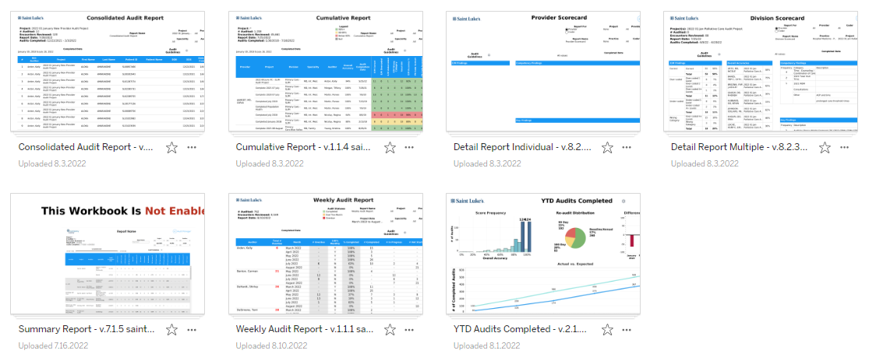

Navigating Interactive Dashboards
All dashboards will have a series of tabs across the top of the screen. These tabs allow you to see different dashboards or printable views of the dashboard.
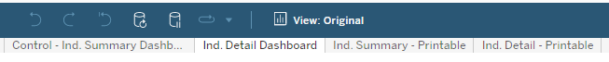

Control Dashboards
The first tab in each report contains filter criteria. Whatever filters are applied to the Control Dashboards automatically filters to all other tabs in the workbook.
If the report has multiple pages there will two tabs with data. Be sure to look at both tabs to see all the data in the report.

Printable Tabs
The remaining tabs in the dashboard are the print ready versions of the dashboards that allow you to print reports or extracted data from Audit Manager. Because the number of Chart Level Comments, Competency Scores, Key Findings and Recommendations can vary greatly between audits. If you have an usual amount of data that does not fit in the area allowed there are separate printable pages so that all data can be printed.

Worksheet Options
On the worksheet there are toolbars, either across the top or bottom, with various actions that can be performed on the worksheet. The function of each button is described below. The View option allows you to save a set of filters, name the filter, and easily see the different views.

Undo: Click this button to undo the last action.
Redo: Click this button to redo the last action.
Revert: Click this button to clear all filters and view the original dashboard.
Refresh: Click this button to refresh data that may have changed in the data source. (Likelihood of data being updated during use is minimal)
Pause: Click this button to pause automatic updates. By default, each time a filter is used the view changes. When adjusting multiple filters it may be helpful to pause updates until all filters have been chosen. (See Resume)
Resume: Click this button to turn automatic updates back on. The dashboard will then update based on the filters chosen.
Original View: When a particular dashboard is viewed regularly with the same filters, it is sometimes beneficial to create a custom view. Each time the custom view is opened, the dashboard displays the information according to those filters. To create a Custom View, open the dashboard, make changes (filters, sorting, zoom level, etc.) and click Original View. Enter a name for the view or choose ‘make it my default’ and click save. When the dashboard is opened in the future, click Original View and select the desired view.
Share: Click this button on a dashboard to create a link that can be shared with a colleague (the colleague must have access to Tableau Server and the workbook).
Download: Click this button to download a dashboard as an image, PDF, or Crosstab (Excel).

Printing, Downloading, Exporting Reports
There are several options for getting data/reports. Click on the Print option and select one of the options below.
Image – screen shot of dashboard. The controls are not printed.
Data – prints the data behind the dashboard in a simple grid table.
Crosstab – exports data to Excel or CSV file.
PDF – creates a PDF file.
PowerPoint – creates a presentation deck. You can print each chart on a separate page in PowerPoint or one page with multiple visuals on my page.
There are several options when printing.
- First you need to select the sheets you want to print or download. If you select All, every tab will be printed. Typically this is not the option you want to select as it will print the control dashboard and all of the extra sheets for unusual printing needs. Most of the time you want to select specific worksheets. To select a worksheet click on the square you want to select.
- Next, select landscape or portrait. Most of the dashboards are in a landscape format.
- Click on Print. Tableau will create a file that will download directly to your browser where you can save it or sent it to a printer.

Glossary of Terms

Dashboards: A business intelligence reporting tool that aggregates and displays data, metrics and key performance indicators (KPIs) in a single screen, enabling users to monitor and examine business performance at a glance.
Tabs: Workbooks will have tabs across the top (like Excel) for dashboards within the workbook. Select the tab that corresponds to the view needed.
Filters: Interactive dashboards contain filters or search criteria, which allow the user to customize the dashboard to specific needs. Using filters allows users to select data they want to view. Choose the appropriate filter options and the dashboard will update accordingly.
Control Tabs: The first tab, in the upper left-hand corner, of the workbook is the Control Tab for the dashboard. Filters applied to this page will automatically be applied to all the dashboards in the workbook.
Tableau Server: An online business intelligence tool that contains data, dashboards, and reports from Audit Manager. Accessing Tableau via the server allows trained Tableau users to create new reports or modify existing reports.
Tool Tips: Hover over data elements to see additional details regarding the data.
Focused View: Within Tool Tips there may be an option titled Focused View. If you click on the Focused View option within the Tool Tip, detailed information for the line selected will be presented.
*Note: The report is not permanently changed based on user actions nor is it
changed for other users. Users should feel free to explore the data.

