AUDITOR PRODUCTIVITY REPORTING
Although Audit Manager does not have a built-in report calculating Auditor productivity, there are several features that can be used to measure how many audits your auditors complete for a given timeframe.
Note: Audit Manager does not track completion dates separately for the Auditor and QA Reviewer. The recorded completion date represents the date the audit was sent to reports no matter if the auditor or QA reviewer sent it to reports. See “QA productivity work-around” section for an alternative work-around to track both completion dates.

HOW TO SEND TO REPORTS FOR PROPER TRACKING
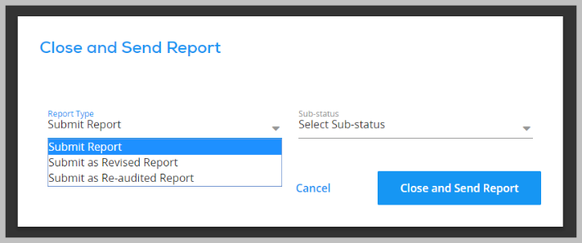
When an auditor or QA reviewer click “Close Send Report”, they get a pop-up that allows them to select the report type. The default is “submit report.” This report type should be used when the audit is sent to reports for the first time.
If the audit is later revised or re-audited, the user should select either submit as revised or re-audited. This will allow the system to track the dates for the initial completion separately from the revised or re-audited completion.

CUSTOM-BUILT REPORT
Within the Reporting section of both Enterprise and Consulting Audit Manager Accounts, users can create their own custom report. All custom-built reports are designed as a spreadsheet with each data field as a column.
Go to Reporting > Custom Reports > Click on Create New Report
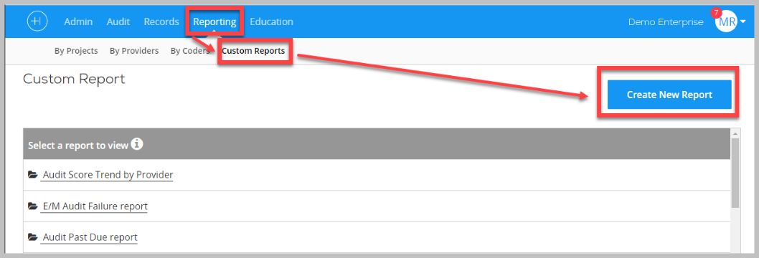
Note: CPT, ICD-10 codes, internal comments, and chart-level comments display on their own row. If a patient has two CPT codes and two ICD-10 codes, there will be four rows for this patient on the spreadsheet. (see screenshot below for example)
We do not recommend including codes in an Auditor Productivity report.
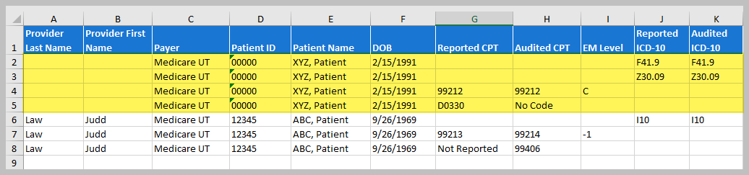

Building the Report
Data from the audits are grouped into categories on the left. Once a category is selected, the audit fields in that category display on the right. Check any field you want to include in the report.

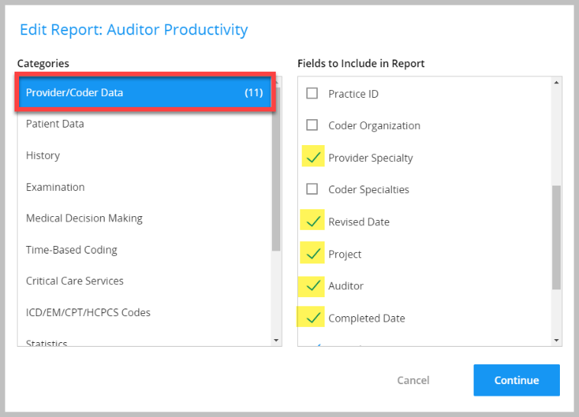
Fields to Consider Including:
- Provider Last Name
- Provider First Name
- Project
- Project Start & Due Date
- Auditor
- Audit Due Date – set upon audit creation
- Completed Date – date the audit is finalized and sent to reports as “submit report”
- Re-audit Date – date the audit is sent to reports as “submit as Re-audited report”.
- Revised Date – date the audit is sent to reports as “submit as revised report”
- Patient Name or Patient ID
- Date of Service
Note: Each DOS will display in the spreadsheet whether any patient data is included. Therefore, we recommend adding in at least the patient ID and DOS so you can differentiate between different dates of service.
After the auditor productivity data is exported from the system, you will need to analyze the data to produce productivity metrics.

AUDIT DASHBOARD
The Audit Work Queue (enterprise) and Audit Projects (consulting) are dynamic, real-time audit dashboards, no matter the status. First, use the Project Created Date ranges to limit the audit data to the desired timeframe. Next, use the funnel icon to filter on additional criteria. i.e. due date, auditor, status.
This dashboard is also exportable. This will allow users to analyze the audit data to determine the number of audits, or dates of service an auditor has completed within a given timeframe.

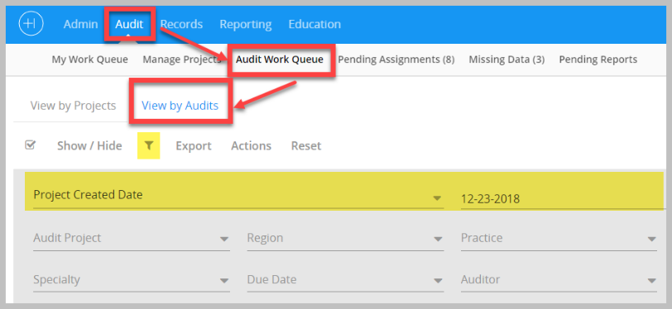
Enterprise Version: Go to Audit > Audit Work Queue > View by Audits > use the project create date range and filters to drill down to the desired data.
Statuses help you understand if the audit has been pulled back or reactivated for a re-audit or to be revised. If it reads “Report Sent–Revised” or “Report Sent–Reaudit”, this signals that the audit was reopened.

Note: the latter two statuses must be selected by the user clicking “close send report” – see “How to send reports for proper tracking” to learn more.
The dates displayed beneath “Complete” are the date that either the auditor or QA Reviewer sent the audit to reports the first time. If the audit is re-audited or revised, the complete date does not change.
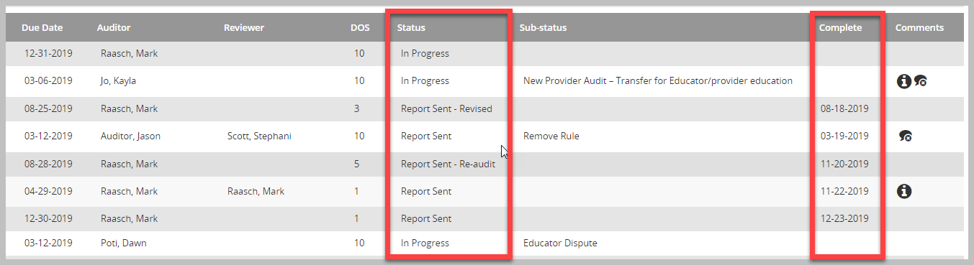
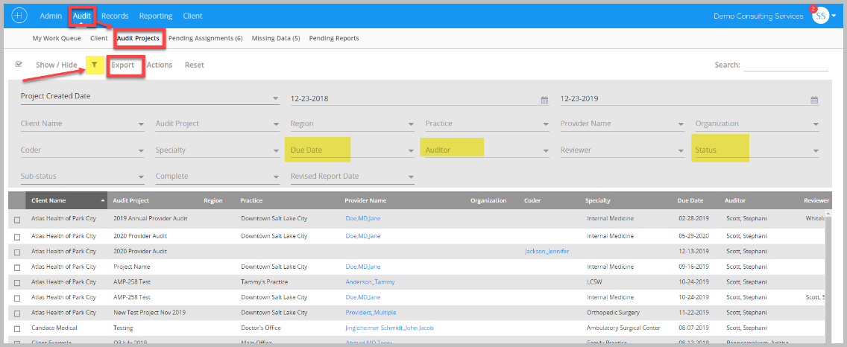
Consulting Version: Go to Audit > Audit Projects > use the project create date range and filters to drill down to the desired data.

QA PRODUCTIVITY WORK-AROUND
To track completion dates for both auditors and QA reviewers, you will need to add a custom field to the audit box. The system will track the date when the QA reviewer closes the audit and sends to reports. Therefore, we recommend your auditors record the date they finished the audit in the custom field.
The custom field can then be added to the Auditor Productivity Report.
Steps to add a custom field to the Audit Box
- Create the custom fields in the Admin Section
Admin Section > Manage Audit Settings > Custom Fields

- Select custom fields you want to include in the Audit Guidelines.
If you want this custom field to show up for all future audits, I recommend adding these fields in your default guidelines. If it’s just for one project, then add them to the guidelines for just that project.
Go to Admin Section > Manage Audit Settings > Audit Guidelines > Click on pencil edit icon to right of Default Guideline > scroll to the bottom of guidelines > select custom fields you want to include > click the (>) arrow to push them to the right. See first screenshot below
