Standard Audit Manager Reports

Individual Provider/Coder Reports - 2 reports
Provider/Coder Detailed Report:  In-depth review of all encounters for the provider or coder.  • Accuracy rates for each code type  • Compares wRVU & Total $  • Detail on each DOS |  | 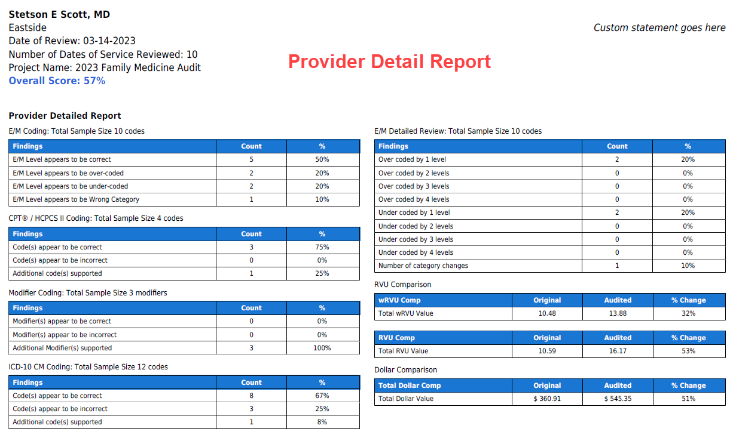
Worksheet Detailed Report:  Excellent for provider education & feedback for those providers that really struggle. Visually displays the audited documentation elements  • History  • Exam, if applicable  • MDM  • Procedure criteria  • Chart Documentation Elements  - Custom fields in Patient Data, Hx, Ex, MDM, Documentation Elements will display. |  | 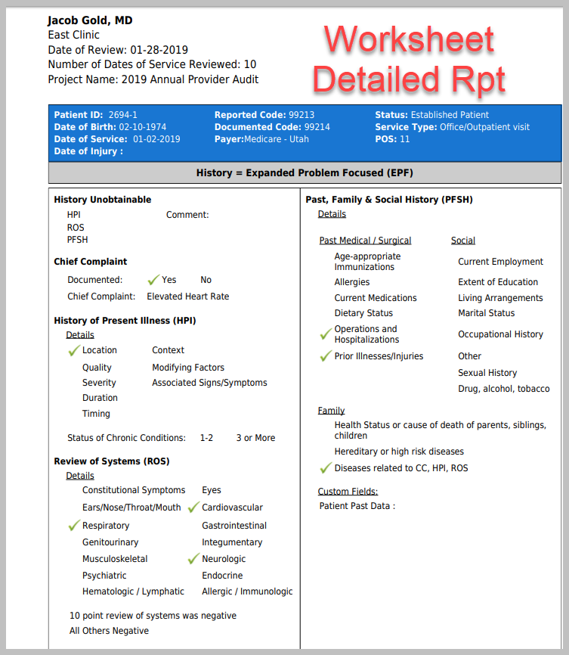
Project Level Reports - 3 reports
Project Data File  Great for advanced analysis; pivot tables, etc. | Raw Data Extract
Project Detail Report (PDF/Word)  Same as the provider detail report; combines all scores for all providers in the audit project  - Birds-eye view of the entire audit project.  - Quickly see problem areas.  - Includes overall accuracy score | 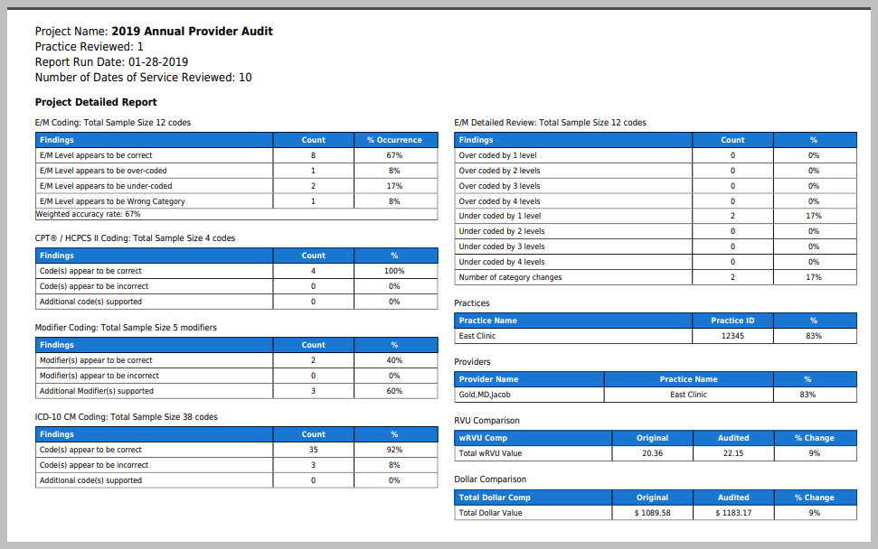
Project Summary (Excel)  Quickly view provider scores, provider comparison & totals for all coding components;  includes overall accuracy scores | 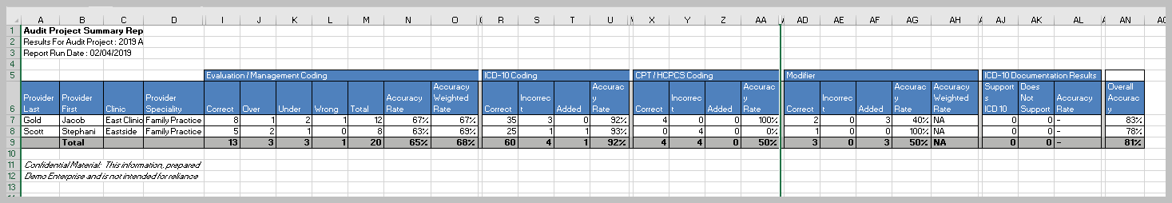

Custom Reports – 7 Reports
Custom reports allow for more customized filtering on the data reported: By practice, specialty, multiple projects at one time
Audit Score Trend by Provider  Excellent educational tool - Charts a provider’s audit scores over time, also a powerful way to demonstrate the effectiveness of your audit program – show how providers are improving overtime with your audit feedback. | 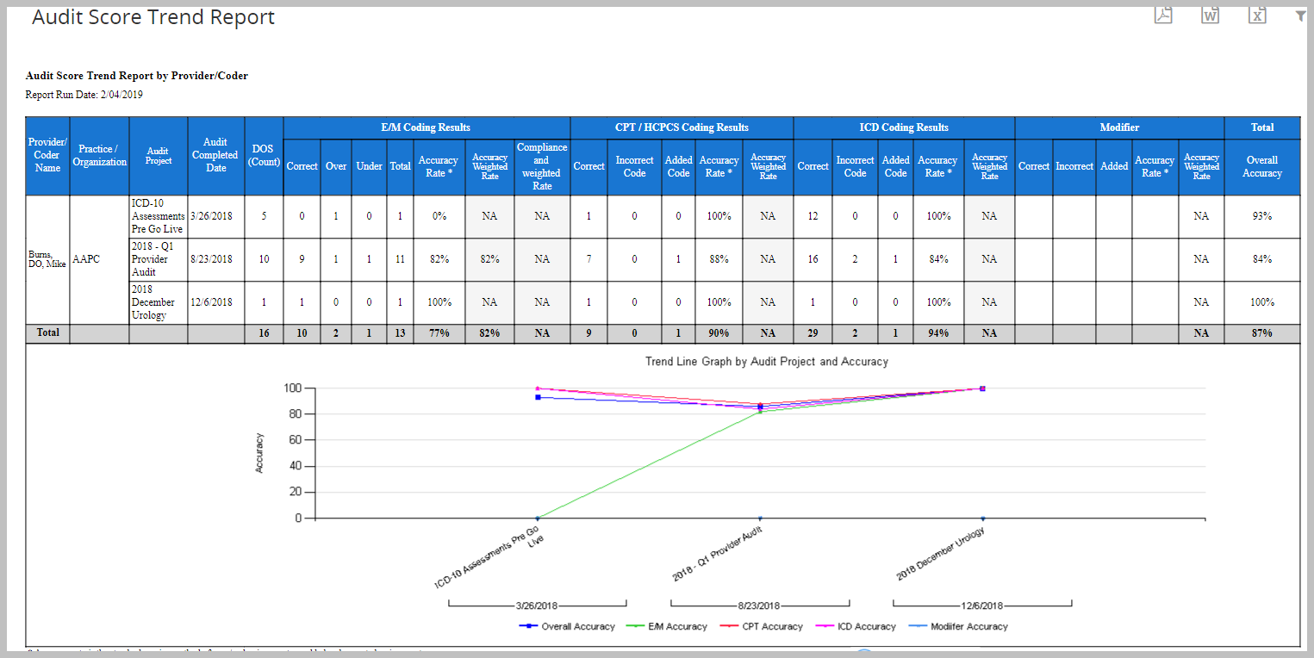
E/M Audit Failure Report  Identify which providers need another audit soon.  • Driven by the Pass Rate Threshold you set for each project  • Threshold legend & actions | 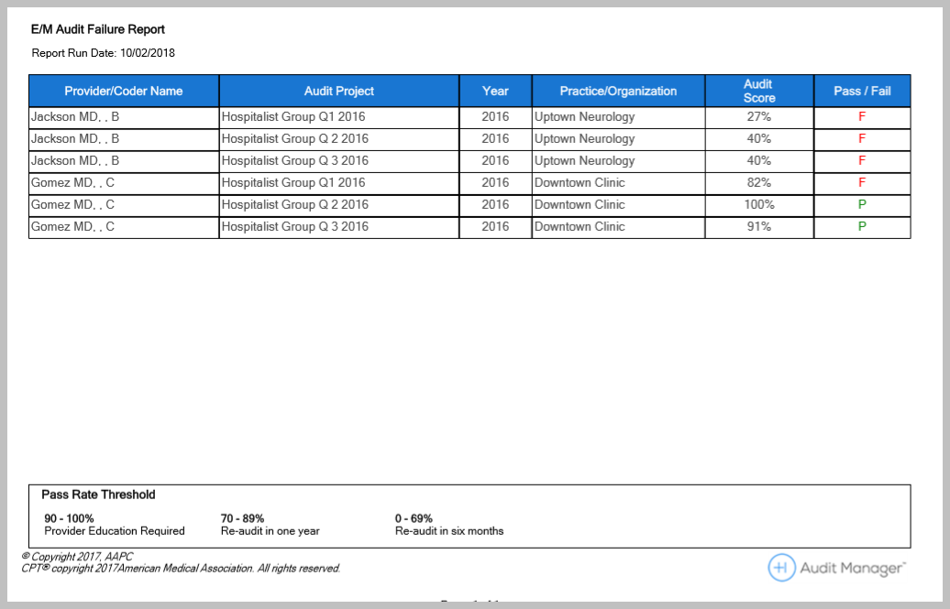
Audit Past Due Report  Make sure all audits are assigned out, allows you to set up audits in advance & then makes sure they do not slip through the cracks | 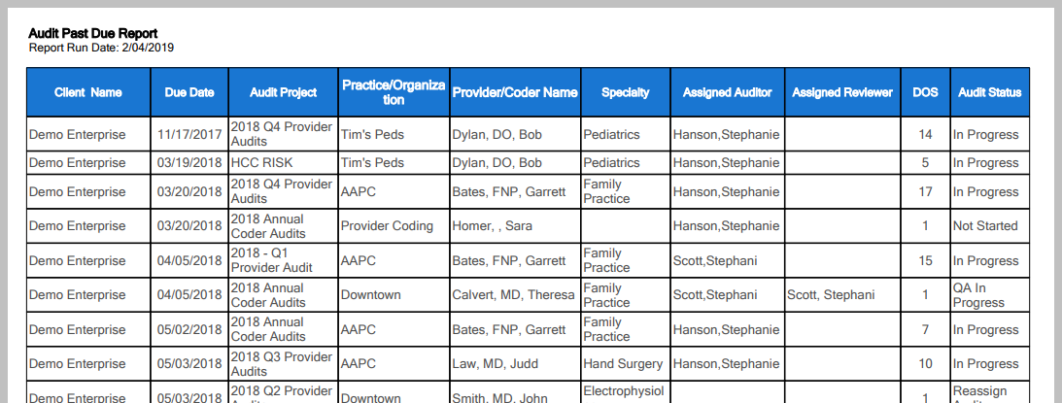
Code Summary Report  Great for determining where you need to focus education – problematic codes.  • Filter by practice, multiple projects, specialty.  • Filter by code  • Filter by modifier | 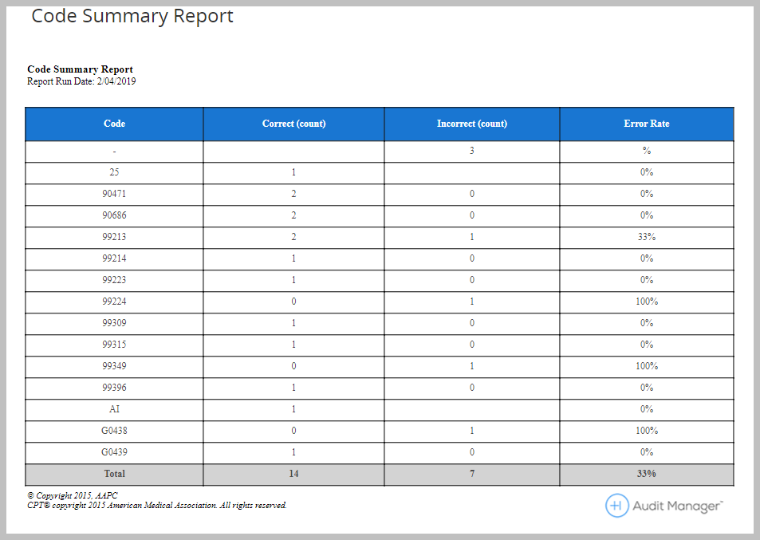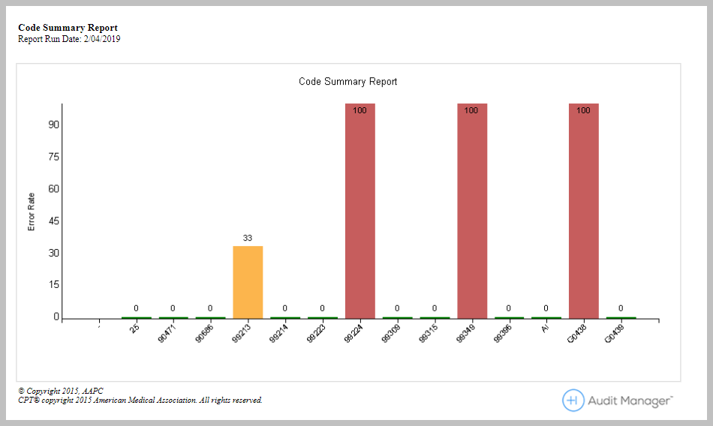
Financial Impact Report  Administration & management will love this report – provides the financial impact of coding accuracy; also helps drive home education for providers  • Filter by practice, multiple projects, specialty.  • Filter by code  • wRVU, tRVU, and Total $ | 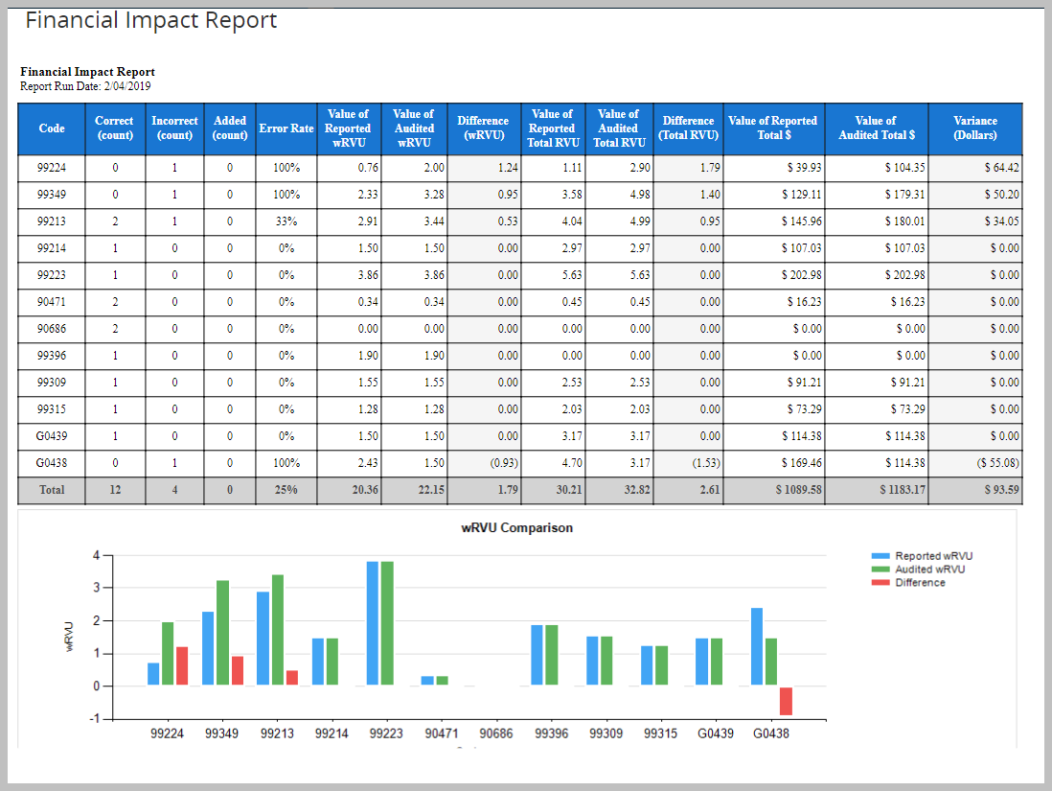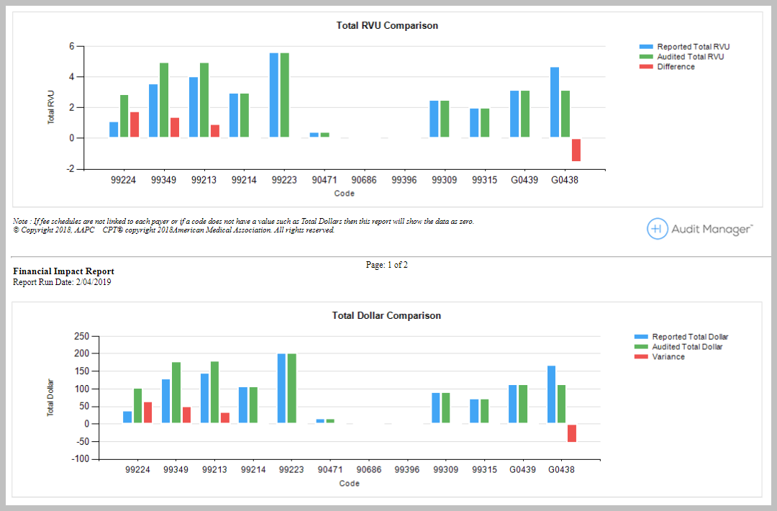
Project Summary Report  Same as Project Summary format, but, more customizable  • include multiple projects  • can filter on specialty  • customize which codes to report | 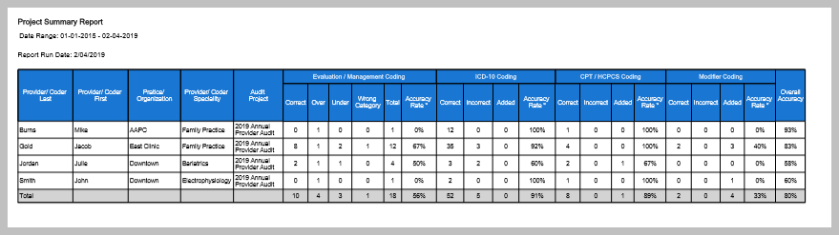
Competency Report  At-a-glance areas to focus provider education.  • Totals by competency area. | 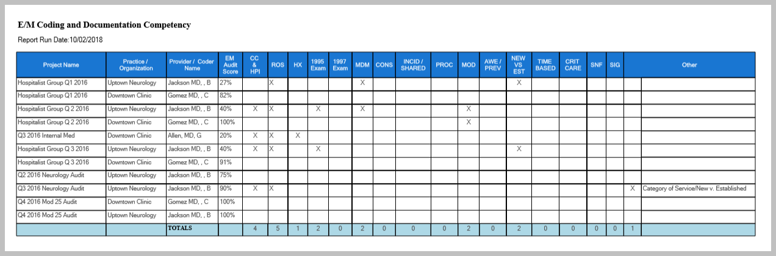
Custom-Report Builder  Create a custom spreadsheet report to pull any fields from the audit for additional analysis and reporting.  - Custom Fields can be included  - Report on feedback comments  - Individual code financial reporting | 