Healthicity

Compliance Manager Incident Management
- Assigning Incident Investigators
- Editing Incident Investigators
- Assigning a Final Approver
- Editing Final Approver
- Marking Incident as Privileged & Assigning a Legal Manager
Incident management options, including assigning an investigator & final approver are accessed through the incident details menu, appearing at the top left of the page.

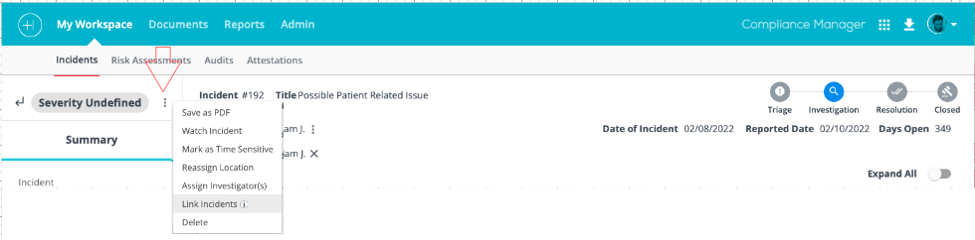

Assigning Incident Investigators
A single or multiple incident investigators can be assigned to an incident.
Step 1.
From the incident detail page, hover over the menu ellipsis appearing at the top right of the in the left panel and select Assign Investigator(s).

Step 2.
Select the investigator(s) by checking the box(s) next to each name in the list and click Next.

Step 3.
Enter the number of DAYS TO REVIEW or select a date from the REVIEW BY DATE field and click Save.

Saving your selection will notify the investigator(s) of their assigned task and due date.

Workflow tip: If assigning multiple investigators, the days to review and review by date will apply to all selected. If you need to assign different due dates, assign the investigators individually.

Editing Incident Investigators
Investigator edit features include the ability to
- Edit Investigation Task Due Date
- Remove an Investigator
- Add Investigators

Edit Investigation Task Due Date
Step 1.
Hover over the menu icon appearing to the right of the investigator's name and select Edit Due Date from the available menu options.

Step 2.
Enter the number of DAYS TO REVIEW or select a date from the REVIEW BY DATE field and click Save

Remove an Investigator
Step 1.
Hover over the menu icon appearing to the right of the investigator's name and select Remove Investigator from the available menu options.

Step 2.
Check the box to acknowledge the warning message and click Remove Investigator.

Add Investigators

Refer to steps 1-3 of the Assign Incident Investigators section above.

Assigning a Final Approver
Step 1.
From the incident detail page, hover over the menu ellipsis appearing at the top right of the in the left panel and select Assign Final Approver.

Step 2.

Select the final approver by clicking into the radio button next to the employee's name and click Save.

Workflow tip: Only one final approver can be assigned to an incident. A due date 24 hours in the future is auto assigned to the Final Approval task. An email notification is generated to the assigned final approver.

Editing Final Approver
A final approver can be removed and another employee can then be named as final approver.

Step 1.
Remove the currently named final approver by clicking the X appearing to the right of the employee's name.
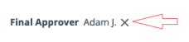
Step 2.
Check the box to acknowledge the warning message and click Remove Final Approver.

Marking Incident as Privileged & Assigning a Legal Manager
From the incident details page

Step 1.
Click the edit pencil appearing at the far right of the Incident section's header.

Step 2.
Scroll to the Mark Incident as Privileged field and toggle the field on.

Step 3.
Click the button that appears.

Step 4.
Select the legal manager by clicking into the radio button next to the employee's name and click .

Step 5.
Click to save the legal manager assignment.

The Legal Manager field will appear in the head, naming the legal manager assigned to the incident.
- Accessing Your Investigation Task
- Documenting Your Investigation
- Editing Your Investigation
While an assigned investigator has the options to add interviews, root causes, corrective actions, status updates, and to add documents, the only requirement to complete the assigned investigation is to complete the investigation task.
The following are important points regarding completion of the investigation task:
- Completing the investigation task notifies the final approver that the investigation is completed.
- If multiple investigations are assigned, all must be completed before the final approver is notified.
- Completing the investigation task moves the incident from the Investigation status to the Resolution Status.
- As an employee level user or manager w/o permissions to view incidents, once you complete your investigation task, you no longer have access to the related incident details page and your investigation task, unless your investigation assignment is re-opened by an admin or manager level user.
- If multiple investigators are assigned to the same incident, each investigator has view access to all investigator's details but can only access, edit, and complete their own investigation task.
Accessing the Investigation Task
Workflow Tip: Clicking the link included with the incident investigation task email notification or accessing the related task from your task list will direct you to the assigned incident details page.
From the Incident Details Page

Step 1.
Navigate down to the Summary of Investigation section and click the related section header to expand the section.

Step 2.
Hover over the menu ellipsis appearing at the far right of your assigned investigation section and select Document Investigation.
Workflow tip: Your name will appear in your investigation section and the menu ellipsis and related options will only appear for your assigned investigation.
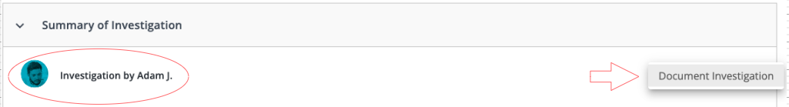
Clicking Document Investigation will prompt the investigation task window to display.
Documenting Your Investigation

Step 1.
Navigate down to the RESULTS OF INVESTIGATION section to populate your investigation details.

Workflow tip: The RESULTS OF INVESTIGATION field is always a required field, denoted by a red asterisk. Your organization may have custom fields as part of the investigation task including required and/or optional fields.

Step 2.
Click to save your changes and complete the task at a future date/time OR .

Workflow tip: Remember that once you complete your investigation task, you no longer have access to the related incident detail page or your investigation task, unless your investigation assignment is re-opened by an admin or manager level user.

Editing Your Investigation Task

Re-access the detail page for the incident you're assigned to investigate from the investigation task appearing in your Compliance Manager task list.

Step 1.
Navigate down to the Summary of Investigation section and click the related section header to expand the section.

Step 2.
Hover over the menu ellipsis appearing at the far right of your assigned investigation section and select Edit Investigation or Clear Investigation to remove all previously documented investigation task details.

If Edit Investigation is selected, follow steps 1-2 of the Documenting the Investigation section above.

- Adding an Interview
- Editing and Deleting Interviews
Available options include:
- Customizing/adding questions
- Uploading/attaching an audio file
- Uploading/attaching documents
Adding an Interview

From the incident details page

Step 1.
Navigate down to the Interviews section.

Step 2.
Click the + icon appearing at the far right of the header to open the Interview window.

Step 3.
Enter the required fields of and .

Options
- Populate any optional fields
- Add questions
- Upload/attach an audio file
- Upload/attached documents

Workflow tip: Note that when attaching a document, you must first name the document for the upload buttons to appear.

Step 4.
Click .

Workflow tip: Once saved, interviews can be re-accessed through the edit feature. At least one must be added for the Interviews section to expand.

Adding Interview Questions
From the Interviews window

Step 1.
Click .

Step 2.
Populate the Question* and Answer * fields (required)

Workflow tip: There is no limit to the number of questions you can add.

Step 3.
Click .

Editing and Deleting Interviews

Editing an Interview

Step 1.
Navigate to the Interviews section and click the header to expand the section.

Step 2.
Hover over the menu icon and select Edit.

Follow steps under the Adding an Interview section above.

Deleting an Interview

Step 1.
Select Delete from the available menu options.

Step 2.
Confirm by answering the Delete Interview warning message.

Step 3.
Click Yes, Delete or No, Do Not Delete.

Root Cause

Who Can Add Root Causes to an Incident?
- Investigator
- Final Approver
- Admin user
- Incident Manager or Full access manager user for the specified location

Add a Root Cause
From the Incident Details Page

Step 1.
Navigate down to the Root Causes section and hover over the ellipsis menu icon appearing at the far right of the header and select Add.

Workflow tip: If no root causes have been entered, only one menu option of Add will appear.

Step 2.
Select one or more root causes and click the button.

Step 3.
Click the button.

Adding a Custom Root Cause
Step 1.
Navigate down to the Root Causes section and hover over the ellipsis menu icon, appearing at the far right of the header, and select Add.
Step 2.
Click .

Step 3.
Populate the ROOT CAUSE field with your custom root cause.
Step 4.
Click the button.

Step 5.
Click the button.

Editing Root Causes

Step 1.
Navigate down to the Root Causes section and hover over the ellipsis menu icon, appearing at the far right of the header, and select Edit.

Step 2.
Follow steps 2-3 of the Adding a Root Cause section above.

Deleting Root Causes

Step 1.
Navigate down to the Root Causes section and hover over the ellipsis menu icon appearing at the far right of the header and select Delete All or Edit to delete individual root causes.
Workflow tip: If no root causes have been entered, only one menu option of Add will appear.

Step 2.
Selecting Edit will open up the Root Causes window. Click the X appearing to the right of the individual root causes you'd like to delete.

Step 3.
Click the button.

Corrective Actions

- Adding Corrective Actions
- Adding Custom Corrective Actions and Related Tasks
- Editing and Deleting Corrective Actions

Who Can Add Corrective Actions to an Incident?
- Investigator
- Final Approver
- Admin user
- Full access manager user for the reported location
- Incident Manager for the reported location

Adding Corrective Actions

From the incident details page

Step 1.
Navigate down to the Corrective Actions section, hover of the menu icon appearing at the far right of the section's header and select Add.

Step 2.
Click .

Step 3.
Select a corrective action from the available list by clicking into the associated radio button.

Step 4.
Click .

Step 5.
Click .

Workflow Tip: Multiple corrective actions can be selected but must be added individually after selecting from the list by clicking the Add Corrective Actions button before clicking Save Corrective Actions.
if Audit, Policy, or Attestation is selected as a corrective action, the related tasks can be created from the incident details page, which links the records. However, the related tasks must be completed before the incident can be closed.

Adding a custom corrective action
At Step 3. above,

Step 1.
Click 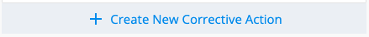.

Step 2.
Name your corrective action in the  field.
If you prefer not to associate Details of Action Requested or a related task, skip to Step 6.

Optional Steps

Step 3.
Add Details of Action Requested in the related rich text field.

Step 4.
Toggle on .

Step 5.
Select a person responsible by clicking .

Step 6.
Select a Due Date and click .

Editing and Deleting Corrective Actions
Editing Corrective Actions
Step 1.
Navigate down to the Corrective Actions section, hover of the menu icon appearing at the far right of the section's header and select Edit.

Step 2.
Edit Details of Action Requested.

Step 3.
Click .

Deleting Corrective Actions

Step 1.
Navigate down to the Corrective Actions and click the header to expand the section.

Step 2.
Delete individual corrective actions by clicking the associated X appearing at the far right.

Step 3.
Click  at the warning message to confirm.

Adding Interviews to an Incident
- Adding an Interview
- Editing and Deleting Interviews
Available options include:
- Customizing/adding questions
- Uploading/attaching an audio file
- Uploading/attaching documents

Adding an Interview

From the incident details page

Step 1.
Navigate down to the Interviews section.

Step 2.
Click the + icon appearing at the far right of the header to open the Interview window.

Step 3.
Enter the required fields of and .
Options
- Populate any optional fields
- Add questions
- Upload/attach an audio file
- Upload/attached documents

Workflow tip: Note that when attaching a document, you must first name the document for the upload buttons to appear.
Step 4.
Click .
Workflow tip: Once saved, interviews can be re-accessed through the edit feature. At least one must be added for the Interviews section to expand.
Adding Interview Questions
From the Interviews window

Step 1.
Click .

Step 2.
Populate the and fields (required).

Workflow tip: There is no limit to the number of questions you can add.

Step 3.
Click ,

Editing and Deleting Interviews

Editing an Interview

Step 1.
Navigate to the Interviews section and click the header to expand the section.
Step 2.
Hover over the menu icon and select Edit.

Follow steps under the Adding an Interview section above.

Deleting an Interview

Step 1.
Select Delete from the available menu options.

Step 2.
Confirm by answering the Delete Interview warning message.

Step 3.
Click Yes, Delete or No, Do Not Delete.

Adding Status Updates to an Incident
- Adding or Sharing a Status Update
- Communicating Back to the Reporter (Compliance Line hotline only)
Available options include:
- Associating documents
- Notifying/sharing the update/comment with another user
- Sending an update or resolution message back to the reporter (Incidents reported through Compliance Line hotline only)
Adding or Sharing a Status Update
From the incident details page

Step 1.
Navigate down to the Status Updates section, click the header to expand the section and click Write New Status Update.

Step 2.
Enter status update or comment in the rich text field.
Options to consider before saving

Options to consider before saving
- Include Attachment - Click to associate a document.
- Share your status update or comment - Type @ or click the @ symbol appearing at the far right of the rich text field, before or after your message, and select the user to share your status update/comment with.
Workflow Tip: If shared, your status update/comment will not leave the system or be included in the email notification sent to the user selected. The user will receive an email notification that a message has been shared with her/him, including a link to navigate to the Compliance Manager Messages list to view it. The message accessed in Compliance Manager Messages will include a link to the related incident.
Note: if the user doesn't have required permissions to view the incident, she/he will not be able to view the incident details.

Step 3.
Click .

Communicating Back to the Reporter (Compliance Line hotline only)

Compliance Line hotline incident details are logged in Status Updates. Any information subsequently added or reported to the hotline by the reporter is also logged in Status Updates. You can initiate feedback or respond to a reporter's request through the Status Updates Resolution option, unique to hotline reported incidents.

The following details how to respond to a hotline reported incident. To log a status update/message without sending it back to Compliance Line, to be communicated to the reporter, select Status Update under SELECT MESSAGE TYPE and follow steps under the Adding or Sharing a Status Update section above.

Step 1.
Navigate down to the Status Updates section, click the header to expand the section and click Write New Status Update.

Step 2.
Click the Resolution button appearing under SELECT MESSAGE TYPE.
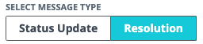
Step 3.
Enter your message in the text field and click.

Communication sent through the Status Updates Resolution feature is transmitted back to Compliance Line and will be Compliance Line operator for communication to the reporter when the individual calls the hotline for an update. If using the Compliance Line web form option, the reporter will see any resolution messages.
Workflow tip: Although the Compliance Manager button is labeled Resolution, messages sent from Compliance Manager to Compliance Line are not labeled as such to the reporter. Only your message is received. Identifying the message as a resolution to the reported issue is up to you.
Uploading Documents to an Incident
- Uploading Documents
- Downloading Associated Documents
- Editing and Deleting Documents
Uploading Documents

From the incident details page

Step 1.
Navigate down to Supporting Documents, hover of the menu icon appearing at the far right of the section's header and select Add.

Step 2.
Enter a (required) and populate any the optional fields named below.
- Describe Process For How Document Was Collected
- Document Was Searched For By
- Location Searched
- Document Belongs To
- Add Note

Step 3.
Click the Computer button to choose a document from your device or Document Center to choose a document from your Compliance Manager Documents.
Step 4.
Click 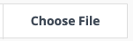.

Step 5.
Select the file and Click .

Downloading Associated Documents

Step 1.

Download All Documents
Navigate down to Supporting Documents, hover of the menu icon appearing at the far right of the section's header and select Download All.

OR

Download Individual Documents

Step 1.
Navigate down to Supporting Documents and click the header to expand the section.

Step 2.
Hover over the menu iconat the far right of the document you want to download and select Download.

Access your downloaded document(s) from the Download Center by clicking the Download icon appearing at the top right of the page in the blue menu bar.

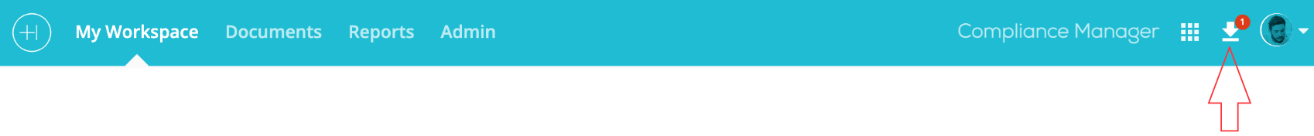
Editing and Deleting Documents

Editing Document Details

Step 1.
With the Supporting Documents section expanded, hover of the menu iconat the far right of the document you want to download and select Edit Document Details.

Step 2.
Make your edits in the Edit Supporting Documents window and click .

OR

Select Remove from the document menu options to delete the individual document and confirm by clicking at the warning message.
Deleting All Documents

Step 1.
Navigate down to Supporting Documents, hover of the menu icon appearing at the far right of the section's header and select Delete All.

Step 2.
Confirm by clicking the at the warning message.

Time Sensitive Incidents

- Tag an Incident as Time Sensitive
- Edit Time Sensitivity
- Identifying Time Sensitive Incidents
Why mark an incident as time sensitive?
Some incidents require an investigation to be completed within a pre-determined time frame. Marking a case as time sensitive will set parameters specific to this incident to help meet a targeted closing date.

Incident management options, including link incidents, are accessed through the incident details menu, appearing at the top left of the page.

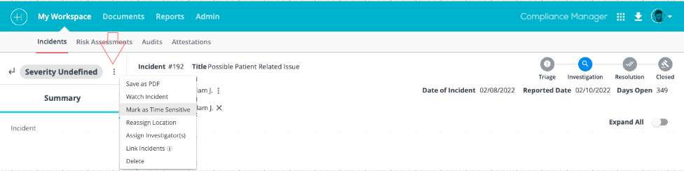
Tag an Incident as Time Sensitive

Step 1.
From the incident detail page, hover over the menu ellipsis appearing at the top right of the in the left panel and select Mark as Time Sensitive.

Step 2.
Define DAYS TO CLOSE or select a CLOSE DATE.

Step 3.
Click .

Step 3 will add a Target Close Date to the incident header.
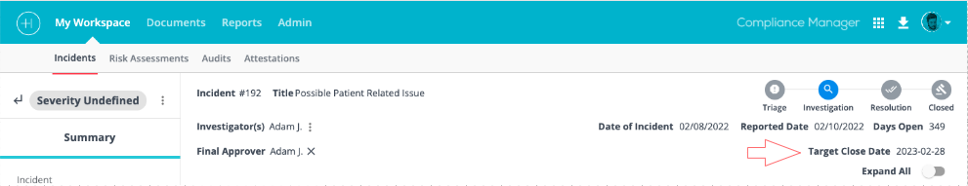

Edit Time Sensitivity

Step 1.
Hover over the menu ellipsis appearing at the top right of the in the left panel and select Edit Time Sensitivity.

Step 2.
Change DAYS TO CLOSE or select a different CLOSE DATE

OR

Click .

Identifying Time Sensitive Incidents

As referenced in step 3 of the Tag an Incident as Time Sensitive section above, incidents tagged as time sensitive will include a Target Close Date in the incident header.

To identify time sensitive incidents from the incident queue (Admin and Manager users only).

Step 1.
Navigate to your incident queue.
Time sensitive incidents will be denoted by a red clock icon appearing to the right of the related Age (Days).

Isolate time sensitive incidents using your queue advanced filter.
Step 1.
From your incident queue
Click the Advanced Filter icon .

Step 2.
Scroll down on your advanced filter lefthand panel to locate and toggle on the Time Sensitive option.

Linking Incidents
- Linking Incidents
- Editing Linked Incidents
Incident management options, including link incidents, are accessed through the incident details menu, appearing at the top left of the page.
Linking Incidents
Step 1.
From the incident detail page, hover over the menu ellipsis appearing at the top right of the in the left panel and select Link Incidents.
Step 2.
Find the incident you want to link by utilizing the quick filter or scroll through the list of incidents within the modal. To link an incident, check the box next to the incident and then click Link Incidents.
Once incidents have been linked, a Link Incidents section will appear at the top right of the incident detail header. Click on the dropdown to view all linked incidents.
Please note:
- The linked incidents section within the incidents detail page will only be shown if incidents have been linked.
- To view a linked incident, click the incident ID # blue text and click the icon. The linked incident will open in a new browser tab.

- Linking one incident to multiple incidents does not automatically link all of the incidents together. For example, I've linked incident #244 to incident #1, incident #4 and incident #7. If I go into incident #1, you will only see it linked to incident #244.

Editing Linked Incidents
Edit from the Incident Detail Menu

Step 1.
Hover over the incident details menu and select Edit Linked Incidents.

Step 2.
Uncheck the box next to the incident(s) you want to unlink and click the Edit Linked Incidents button at the bottom of the modal.

or

Locate the incident you want to unlink in the Linked Incidents dropdown list and click on the 'X' appearing to the right of it.
Edit Incidents in Closed Status
Closed incidents can be edited without having to re-open the incident.

Workflow tip: Re-opening an incident will move the status from Closed to Resolution. When closed again, a new close date will be assigned.
From the incident details page

Step 1.
Access the details section you want to edit and click the action icon or select an action from the available section menu options.

Step 2.
Answer the prompt to confirm your intention to edit an incident in Closed status.

Step 3.
Document and save your additions and/or edits.

Reopen/Reassign Completed Incident Investigation
Admins, Full Access Managers and Incident Managers (with permissions to access the incident) can re-open a completed incident investigation.

Re-opening a completed investigation

Navigate to the related incident detail page. Incident investigation assignments appear at the left of the incident header. Completed investigations will include a blue checkmark to the right of the investigator's name.


To re-open the investigation, hover over the menu icon appearing to the right of the blue checkmark and select Reopen Investigation.

Re-opening an investigation task will prompt the following.

- The investigator, if an employee user, will be granted access to the incident details again.
- The investigation status will change from Resolution to Investigation
- The blue checkmark will be removed
- The investigation task status changes from Completed to Ongoing
- An email message is generated to the investigator whose investigation task you've re-opened, indicating that an incident investigation task has been re-assigned. See sample email below

Hello {{recipient_name}},

An incident investigation has been re-assigned to you by {{name}}. Please review {{incident_id}}

and complete the investigation by {{due_date}}.
{{incident_investigation_link}}

- The incident investigation due date will be 30 days from the day the investigation was re-opened.
Workflow Tip: You can edit the investigation due date by clicking the menu ellipse to the right of the investigator's name and selecting Edit Due Date from the available menu options.
- The incident record activity log will document that the incident was re-assigned and who made the change. See sample activity log message below.
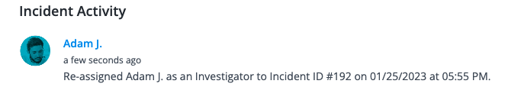
Incident Detail PDF

- Creating a PDF From the Incident Queue
- Creating a PDF From an Incident Detail Page

Creating a PDF From the Incident Queue

From the incident queue

Step 1.
Locate the incident in the queue and click the menu ellipsis appearing at the far right of the line item to produce the menu options. Select 'Save as PDF'.

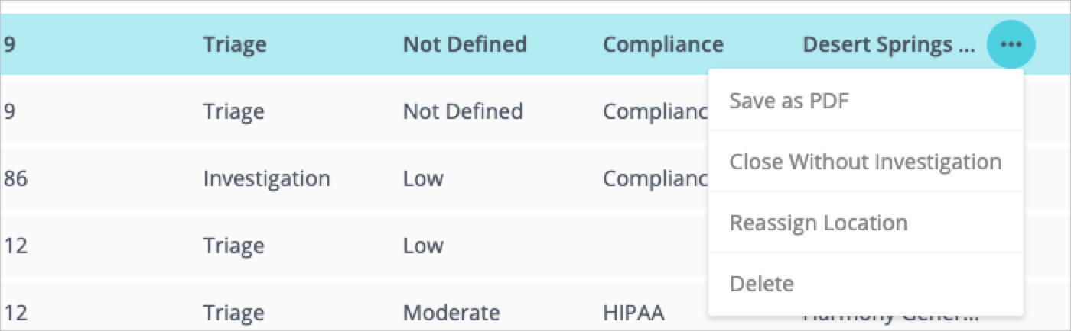

Step 2.
Check the box(s) next to the section(s) you'd like included in the PDF and click 'Save as PDF' to start download.

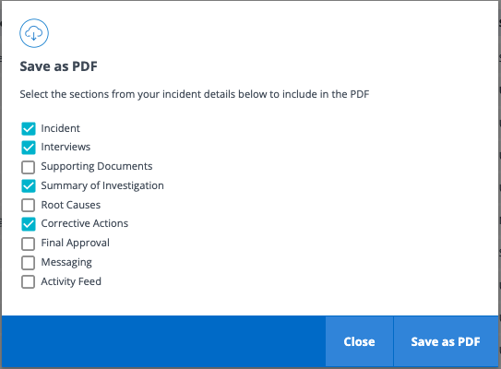
Access the PDF from the download center appearing at the top right of the page.

Step 3.
Click the Download Center icon to produce the list of available downloads.

Step 4.
Download the PDF by clicking the download arrowor share the document via email by clicking the mail icon , both appearing to the right of the title.

Workflow tip: You can share the document via email with anyone having access to Compliance Manager. The selected individual will receive an email notification of the shared document with a link to their Compliance Manager Messages list, where they can view the PDF.

The shared document is not attached to the email notification.

Creating a PDF From an Incident Detail Page
From the incident details page

Step 1.
Hover over the incident details menu appearing at the top left of the screen and select Save as PDF.

Follow steps 2 - 4 above.

